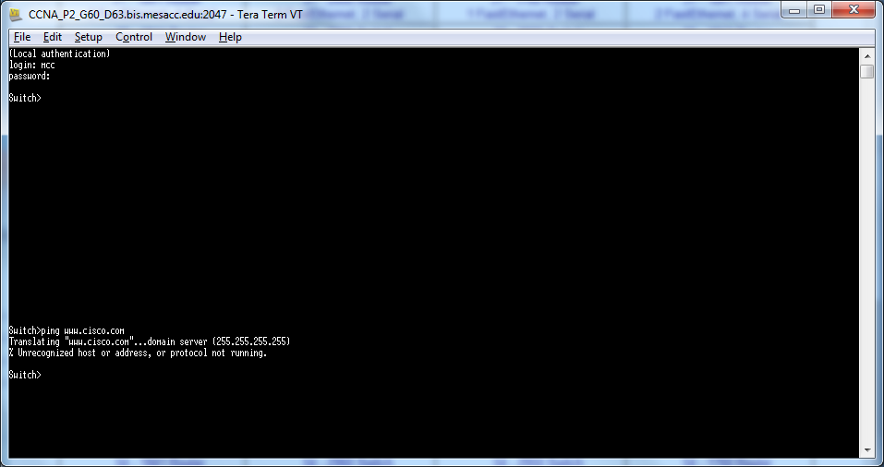
Ping checks if a website’s server is reachable.

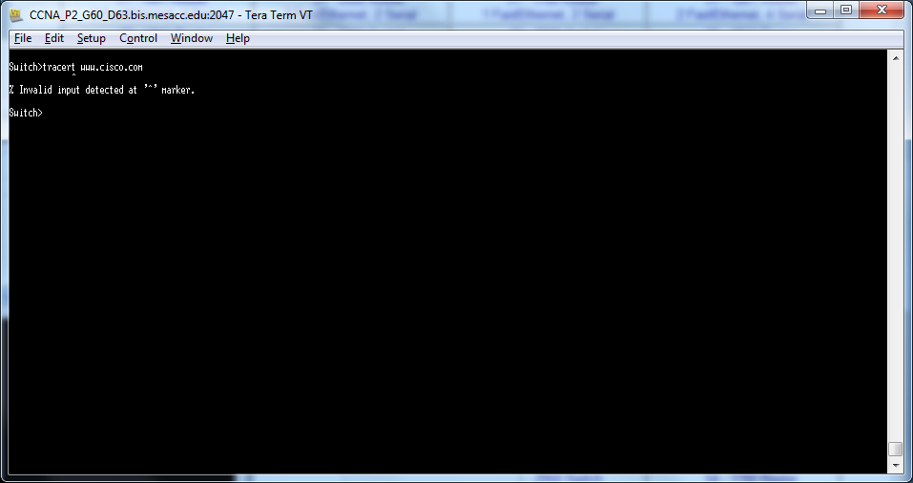
Tracert determines what route your computer will take across the Internet to reach a server.

Both Ping and Tracert test your connection to the internet. Their differences are already mentioned above, so I won’t retype the same text.

